FACILITATOR’S NOTES
Happy New Year to All our Members of the WSAC Genealogy Group.
I hope that the Holidays were enjoyable for everyone, and that you are able to continue to enjoy the pursuit of your family heritage in the year ahead.
We are now halfway through our 2025-2026 Season, and I want to thank everyone for your continued support of our group activities. Several members have facilitated our sessions, and I hope that the topics we have provided have been valuable and interesting to everyone. My objective continues to be to offer learning and understanding of genealogy so that everyone can pursue their family heritage with confidence and with as many available tools as possible.
I look forward to your continued support and participation in the months through to June and always welcome your input and participation.
Thanks everyone, Sincerely, Paul.

TOPICS, TOPICS, TOPICS…  We are in the last half of the 2025-2026 Season for our Genealogy Group. It is time to think ahead to next season and give some thought as to what topics the group would like to see in next year’s agenda. We have many experienced members who have pursued genealogy for several years, as well as members who are new to genealogy and looking for tips, guidance and assistance. I hope our discussions are meeting the needs of everyone, and that future topics will continue to be of value to the group. We could look at bringing back topics we have formerly discussed, or welcome new issues that will provide learning and interest for everyone. |  | 
If we need to source an external presenter for any of these topics, that often takes some time and
pre-planning, so hence my call for your suggestions.
All suggestions are welcome. Please just email me at prose0849@gmail.com

SIGNING IN AT OUR GENEALOGY MEETINGS:
We are having some difficulty with our signing-in procedure at our monthly Genealogy meetings and I wanted to review the procedures with everyone. When you arrive at our meetings, there will be two sheets that require your signature:
1. A Yellow Attendance Sheet: This sheet is for our own internal meeting records. Everyone is asked to sign their name on the sheet and indicate if they are a New (N) or Returning (R) member. If you are a New Member (or an existing member and you have changed your email address), please provide your current email address beside your name. This will put you on our Email Distribution List and ensure you receive upcoming meeting information, genealogy tips, etc.
2. A White Attendance/Payment Sheet: This sheet is for WSAC Administration. Everyone is required to sign their name as an attendee and provide the required $3.00 drop-in fee. Please indicate how you made this payment: In cash (which you placed in the payment tin) or payment from your Wallet/Bank held with WSAC.
We are required by WSAC to reconcile the number of attendees and the payments after each meeting. Your kind attention to this process is most appreciated.
UPCOMING MEETINGS
Wednesday March 4. 2026  There will be two Topics:  1. Cemetery Records and Family Research.    The value of information found in cemeteries and cemetery records goes unsaid. Thea Hawryluk will be presenting on the sources available using cemetery records to research your ancestors. These records provide a fascinating insight into the story of our family above and beyond just names and dates.  2. Using Land Records in Family Research.  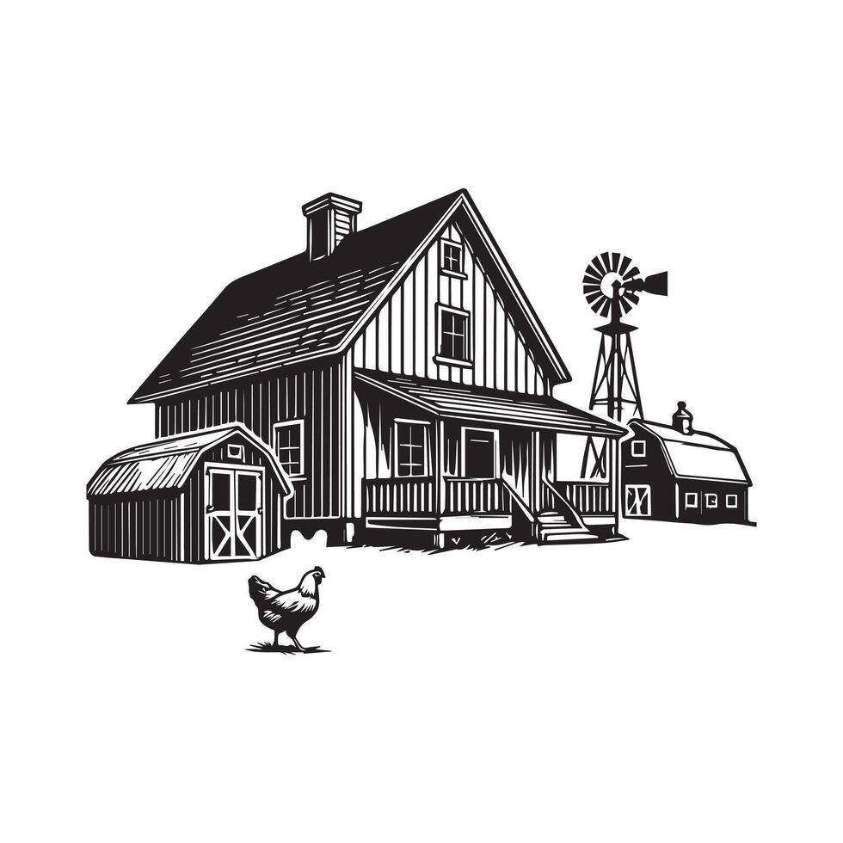  Land records will often reveal great detail on the lives of our ancestors. Paul Rose will facilitate a look at the history of land ownership in Alberta through homestead records, land titles records and show how to access these valuable sources of family history. | Wednesday May 6. 2026  There will be two Topics:  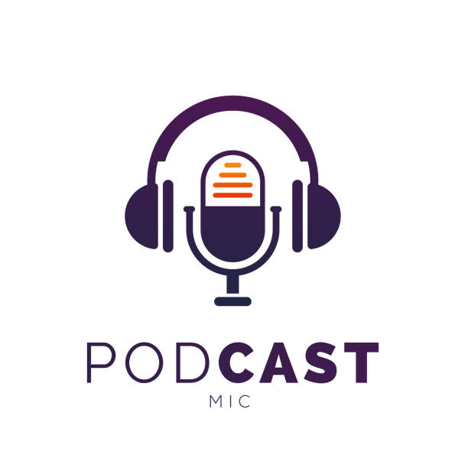  1. Genealogy Gems by Lisa Louise Cooke facilitated by Ashley Rother. Lisa Cooke is the author of a variety of multi-media materials around the topic of genealogy. Through her free pre-recorded audio shows, she has covered genealogy topics on Solving Genealogy Problems, Newspaper Research, A Beginner’s Guide to Genealogy, Using AI in Family Research, and a host of other topics. Ashley will introduce us to using Lisa Cooke’s Podcasts as a useful resource in our pursuit of our family history.  2. Hiring a Genealogist Researcher:  Seeking the assistance of an external genealogy researcher is often useful when we have run into a brick wall in our research, or distance is a factor in our efforts to learn more of our family’s past. Paul will facilitate a look at what options are available in ‘Hiring a Genealogy Researcher’.  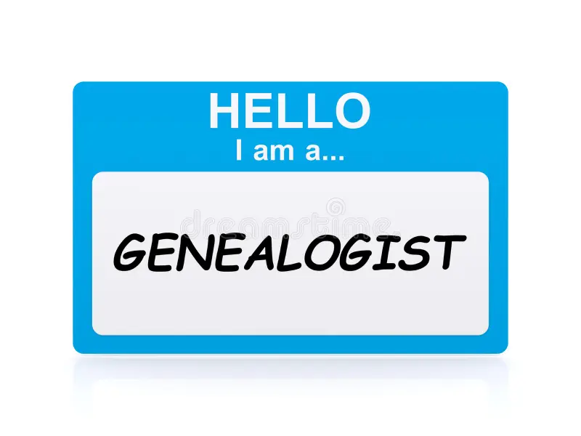
Wednesday April 1. 2026  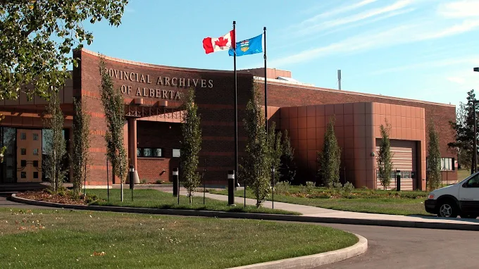  We are going offsite! On April 1 we will be gathering at the Alberta Provincial Archives in Edmonton to learn about the resources available to us through their records and holdings. The Archives offers a wide range of research options which their staff will describe as well as provide time for personal research. Further information about our trip is found later in the newsletter | Wednesday June 3. 2026  For our final meeting for the 2025-2026 Season we have invited Jean-Yves Vanier-Verbeek back to speak on the topic of “What To Do with My Family History Research Records?”. Jean-Yves will provide us with insight into the various options that we have to perpetuate the records and history of our families for future generations. This is a much-discussed issue for family historians and one that should offer some options and suggestions.  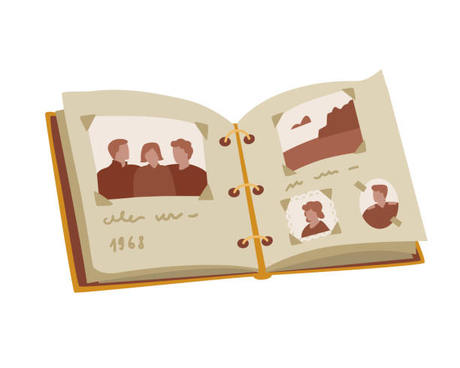

A Quote:

“Eventually, all genealogists come to their census.”
FIELD TRIP TO THE PROVINCIAL ARCHIVES  Wednesday April 1, 2026  Our meeting for Wednesday, April 1. 2026 will be offsite at the Alberta Provincial Archives located at 8555 Roper Rd. NW, in Edmonton. Those members wishing to take advantage of this research opportunity are required to use their own personal transportation to the archives, there is plenty of free parking available adjacent to the building. Pre-registration is required and I will endeavour to have the necessary forms available at our February and March meetings for those wishing to attend. Registration forms will also be available at the archives on the day of our visit.  A tour of the APA facilities will be provided, and members will be permitted to research the archives holdings for probate records, homestead records, township maps, teachers’ Pension Ledgers, Criminal Prosecution files, Proof of Age documents, and a number of local histories, town directories, church records and indigenous resources. | 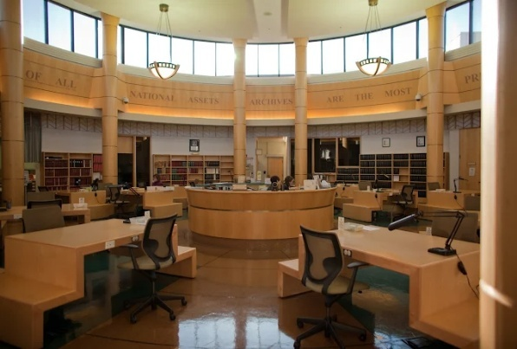

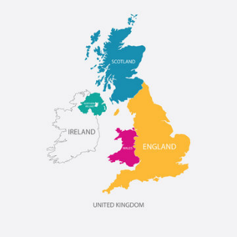 | NEW BRITISH VITALS WEBSITE  The website for FREE Birth, Marriage and Death (BMD) index records for England and Wales from the General Registrar Office has been redesigned. Users can expect faster and more efficient searches, autosuggest tools, refined filtering options, and improved citation and download capabilities. The site’s design is also more accessible and responsive to mobile devices and tablets. Check this new site out at www.freebmd2.org.uk

BRITISH ANCESTORS IN INDIA  If your ancestors were among the millions of Brits who lived in India during the Empire rule, there are websites available to assist you in tracing their lives. The reign of the British in India began when the East India Company established dominion in the country in 1757. The British government then ruled India from 1858 until India gained independence in 1947. Whether they worked for the government, the army or trading companies, many people in Britain can trace their family history back to the British in India. These websites are a good place to start with researching your British Indian family history.  There are five useful websites that can assist in researching ancestors who resided in India:  1. Families in British India Society: www.fibis.org  2. Find My Past: www.findmypast.co.uk  3. National Archives of India: https://www.nationalarchives.nic.in  4. Family Search - India Genealogy: www.familysearch.org/en/wiki/India_Genealogy  5. Expert’s Choice – British Association for Cemeteries in South Asia (BACSA):  www.bacsa.org.uk |  | 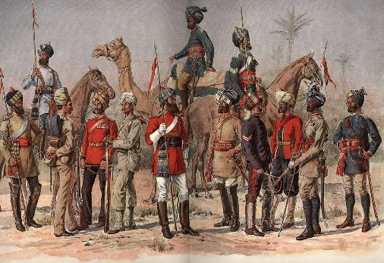
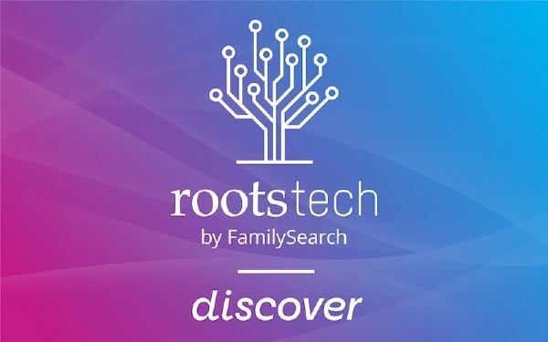 | UPCOMING EVENTS  I have sent out an email with a list of upcoming events that may be of interest. It is difficult to include all events as there are many genealogy presentations, webinars, podcasts, and in-person workshops and seminars happening regularly. Below are listed the following groups for some current, local genealogy happenings:  1. Alberta Genealogy Society – Edmonton Branch: https://www.abgenealogy.ca/  2. The Ukraine Genealogy Group – Edmonton and Area Society: Elaine Kalynchuk, President, puts out a monthly  e-newsletter with an extensive listing of local, national and inter-national genealogical events. Her newsletter is free and can be obtained by requesting receipt by emailing Elaine at kalyna@outlook.com  3. RootsTech is Coming – March 5 to 7. 2026 in Salt Lake City, Utah:  RootsTech is the world’s largest Genealogical conference and is held annually at the Genealogical Library of the Church of Latter Day Saints in Salt Lake City. There are two options available to participate in this event:  A. Attend in Person by Registering at https://www.familysearch.org/en/rootstech/registration  You have the option of attending for 1 day or 3 days. There will be 250 sessions to choose from.  B. Attend Online by Registering at https://www.familysearch.org/en/rootstech/registration/online  Here you can enjoy upwards of 200 different sessions from the comfort of your home. These sessions will be available online for several weeks after the March conference.

NEWSLETTER INSERT  Do you have something you would like to contribute to our newsletter? I welcome any suggestions, inserts, articles etc. that you feel would be of interest and value to our group and ask that you email them to me at prose0849@gmail.com and I will gladly add them into future newsletters. Genealogy is all about sharing information with others. | 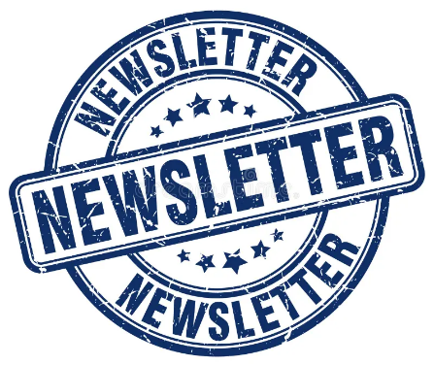

A Quote from Bob Hope

I grew up with six brothers. That’s how I learned to dance -waiting for the bathroom.”

MY HERITAGE INTRODUCES NEW DNA TESTING PROCESS:

MyHeritage recently introduced major upgrades to its DNA testing, shifting to Whole Genome Sequencing (WGS) for more comprehensive, accurate results at no extra cost, making them a leader in consumer WGS. Alongside this, they launched Ancient Origins, a deep-dive analysis of ancient DNA, and DNA Traits, exploring genetics behind personality, nutrition, and fitness, all powered by advanced technology like AI for results.
Whole Genome Sequencing (WGS) is an upgrade from reading 700,000 markers to the entire 3 billion base pairs of the human genome, leading to more precise ethnicity breakdowns and DNA matches.
I recently participated in this new DNA testing analysis and have just received the results back. Without having completed much analysis of the results, I can offer the following:
1. Order you Kit at www.myheritage.com. The kits are presently offered at $45.00
2. Follow the instructions in the kit using care not to contaminate your DNA sample.
3. Mail your sample back to My Heritage in Texas using the pre-addressed envelope.
4. In order to mail your sample, you must complete two customs/tariff forms that you will present at the Postal Station:
A. You need a US Customs form to send the kit to the US:
Go to https://www.canadapost-postescanada.ca/cdc/en/customs-form
Completion: Your Name and Address
Recipient Details: MyHeritage, US, their address on the self-addressed envelope.
I used my telephone number.
Reason for Sending: Other - Sample
Failed Delivery Option - Return to Sender
Package Content: 1
Detailed Description: Buccal cells in solution
Country of Origin: Canada
Quantity: 1
Value: enter '1" it will automatically change to $1.00. Then it goes to a screen that says your form has
been successfully submitted and shows the QR code. This code has apparently gone to the post
office, but copy it onto your phone or print it and take with you just in case.
B. You also will need a USA Declaration ID to indicate that duty has been paid on the mailing. To
prepay your duties, you need to download the free Zonos Prepay app available for IOS and Android
devices in the Apple or Google Play stores to create a Declaration ID and pay the duties. You can
do this before visiting your Postal office. A web version is available at app.zonosprepay.com. We
placed the QR code on our phone and the postal clerk scanned the code for processing the mailing.
The duty cost for sending a DNA sample was $10.20. Thank Mr. Trump for this additional
confusion and cost.
Our DNA results were available by email link within 4 weeks. Without having reviewed the results to great detail, they will show:
A. Overview: provides an Ethnicity Estimate.
B. Ethnicity Estimate: Is a map (in my case Europe) showing the countries of origin and the percentage to each
C. DNA Matches: Lists your matches to other users. It quotes the individuals name, possible relationship, DNA match quality, shared DNA percentage, shared segments. There is a link to contact the individual.
D. Ancient Origins: A detailed report that you request and will be available with 24 hrs.
E. DNA Tools:
i. cM Explainer – a tool for suggesting how you might be related.
ii. Chromosome Browser – a tool for viewing shared DNA segments between you and multiple DNA matches which can help point for a common ancestor.
iii. Auto Clusters – an automatic tool to organize your DNA matches into clusters that likely descended from common ancestors.
iv. Ethnicities Map – discovers the most common ethnicities in each country and finds out the top countries for each ethnicity based on data from My Heritage DNA users.

