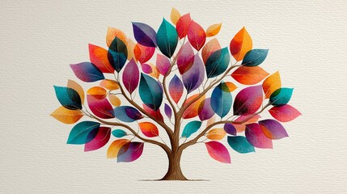 | Facilitator’s Notes  So far this season (2025-2026) we have had a number of very interesting presentations at our monthly meetings. I want to thank everyone who has helped make these meetings informative and entertaining. I also want to thank those members who have provided information for this newsletter. Your information has helped make the newsletter that much more valuable to all of us who pursue knowledge of our family heritage. Thank you. Paul
My Heritage Upgrades Its Consumer DNA Tests to Whole Genome Sequencing

The My Heritage DNA tests have been upgraded to Whole Genome Sequencing, the most comprehensive method for reading DNA available today. My Heritage is the first major consumer DNA testing company to adopt Whole Genome Sequencing at a large scale, enabling them to deliver more accurate DNA Matching and ethnicity results, and create opportunities for exciting new products in genetic genealogy.

What does this mean?
The Genome Sequencing reads almost the entire human genetic code covering around 3 billion base pairs. This increased data enables deeper insights across all types of genetic analysis. Only new DNA kits will participate in this new analysis, older processed kits will not be reprocessed with the new technology. The new technology will create new opportunities for the delivery of deeper insights into ethnic origins, family connections, and genetic genealogy without any price increase to consumers.

My Heritage is committed to the privacy and security of its consumers’ data. All genetic data is encrypted and stored securely, nor does My Heritage sell or license data to third parties. All genetic samples are destroyed after processing which provides peace of mind.

For more information;
https://blog.myheritage.com/2025/10/myheritage-upgrades-its-dna-tests-to-whole-genome-sequencing/

Ancestry releases new DNA Updates:
Ancestry has released its Ancestral Origins 2025 Update, a significant overhaul of its DNA analysis reporting. This update introduces greater regional specificity, a new organization structure, and re-analysis of all user DNA data, which may result in changes to individual ethnicity percentages.
Key Changes in the 2025 Update:
- Expanded Reference Panel: The update is powered by an expanded reference panel of more than 185,000 DNA samples allowing for more precise comparisons.
- Increased Regions: The total number of global regions available for analysis has increased significantly to over 3,600 places around the world.
- Greater Granularity: Many broad regions have been broken down into smaller, more specific areas. For example, the previous ‘Ireland’ region is now separated into four new sub-regions.
- New ‘Macro-Regions’: Results are now organized into larger, stable ‘macro regions’ with more specific regions ‘nested’ underneath. The results are then easier to understand and still provide detailed information.
- Decimal Percentages: The update introduces decimal percentages for ethnicity estimates which can reveal smaller trace amounts of ancestry.
- Re-Analysis of All DNA: Every Ancestry DNA user’s DNA was re-analyzed with the new science leading to changes in the percentages and specific regions displayed in their results.
Ancestry emphasizes that your actual DNA has not changed, rather what has changed is the amount of data available and the scientific methods used to interpret it. As more people from diverse backgrounds take the test, the reference panel grows allowing scientists to make finer distinctions between closely related populations.
Here’s A Youtube describing the new DNA Updates:
https://www.youtube.com/watch?v=owrqIDF7ajg&t=9s
The Twelve Days of a Genealogy Christmas  On the Twelfth Day of Christmas,  My True love gave to me,  Twelve Deeds and Titles,  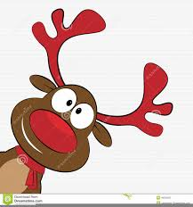  Eleven Probate Problems,  Ten Lost Relations,  Nine Legal Letters,  Eight Manorial Records,  Seven Census Searches,  Six GEDCOM’s downloaded,  Five Old Wills,  Four Christening cards,  Three French connections,  Two CD titles,  And one fully completed Family Tree!!  Courtesy of Irene Powell |  | FREE!! CDs and Books  I have been approached by a lady who has some British CDs and books she wishes to give to an interested fellow genealogy researcher.  The items:  CD sets:  - 1841 Surrey, England census.  - 1841 Middlesex, England census.  - 1841 Kent, England census.  - Parish records of Hendon, England  1801-1811 and 1821 census.  - Universal British Directory 1791.  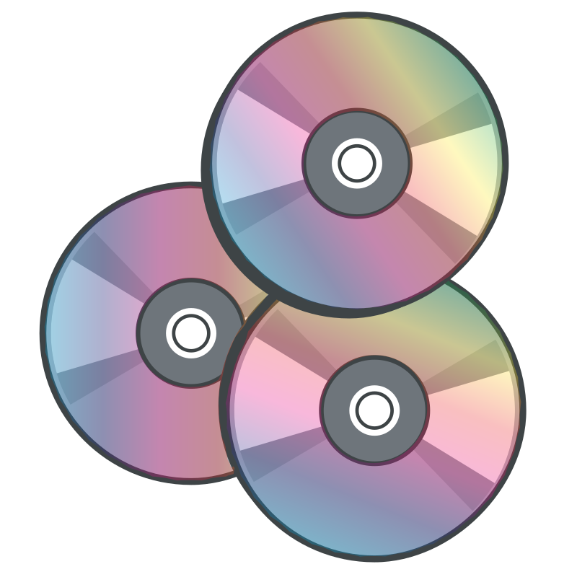  Book: “Unlocking the Secrets of Old Photos”.  If interested, please email me at prose0849@gmail.com and I will connect you with the owner.
The Ultimate Genealogy Record List  From Family History  Ashley submitted this guide and checklist from Family History Daily Online Learning Center which contains nearly every major record type that can help you discover more facts about your ancestors. They are organized by categories which are listed in order of importance to developing genealogical proof.  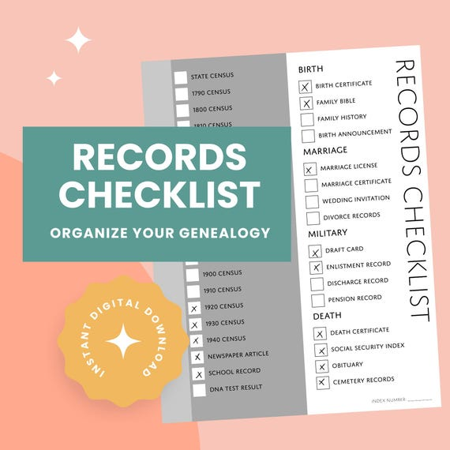  The guide is in two parts:  Part One: helps you understand each record category and how it can help you with your research as well as the main record types found within that category.  Part Two: provides a simple checklist of these record types by category. This can be used to gain new ideas for where to research for your ancestors and to keep track of records you have already searched.  The checklists can be found at:  https://learnfamilyhistory.com/genealogy-record-checklist  Courtesy of Ashley Rother |  | A Book To Read:  “The Little Immigrants by Kenneth Bagnell”  The Little Immigrants is a tale of compassion and courage and a vivid account of a deep and moving part of Canadian heritage. In the early years after Confederation, the rising nation needed workers that could take advantage of the abundant resources. Until the time of the Depression, 100,000 impoverished children from the British Isles were sent overseas by well-meaning philanthropists to solve the colony's farm-labour shortage.  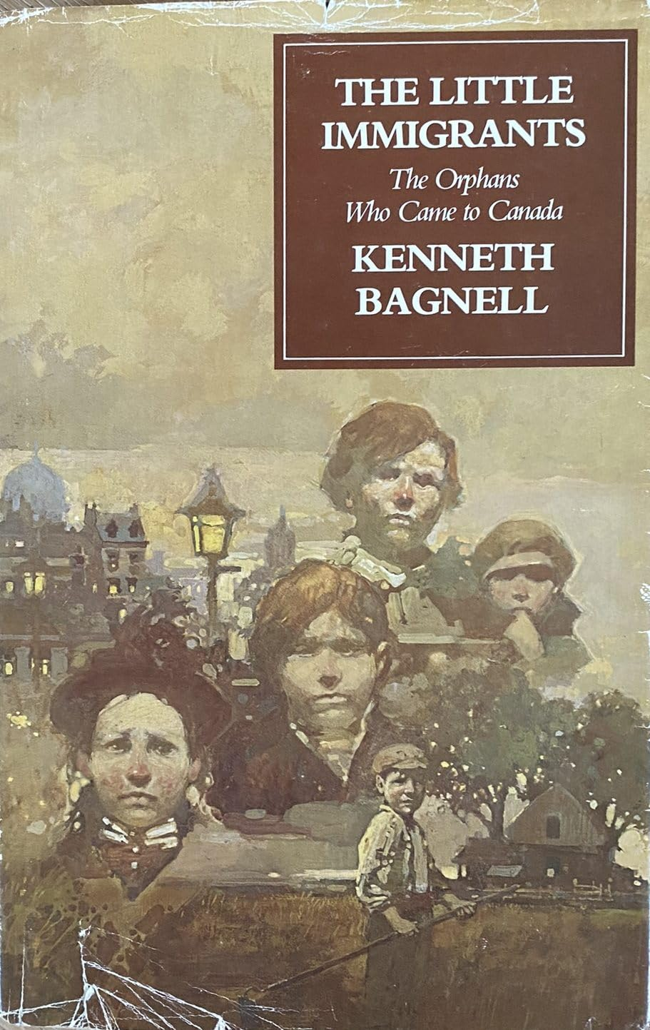  Known as the "home children," they were lonely and frightened youngsters to whom a new life in Canada meant only hardship and abuse. This is an extraordinary but almost forgotten odyssey that the Calgary Herald has called, "One of the finest pieces of Canadian social history ever to be written."
The WSAC GENEALOGY GROUP WEBSITE

Remember to check into our Genealogy Website for information on:
- Upcoming Topics for the next 3-4 months.
- Archived Topics – summary notes for past meetings.
- Helpful Genealogy Websites – many of the websites that were referenced in our past meetings.
- Genealogy Software Options – a comparison chart of some of the more popular genealogy software for recording your family research findings.
- Group Newsletters – our past newsletters since November 2024

The website belongs to all members of our Genealogy Group. Feel free to add articles, information, research tips, etc. that you feel would be of value to other members. Simply send me an email (prose0849@gmail.com) with your information and I will have it added to the site.
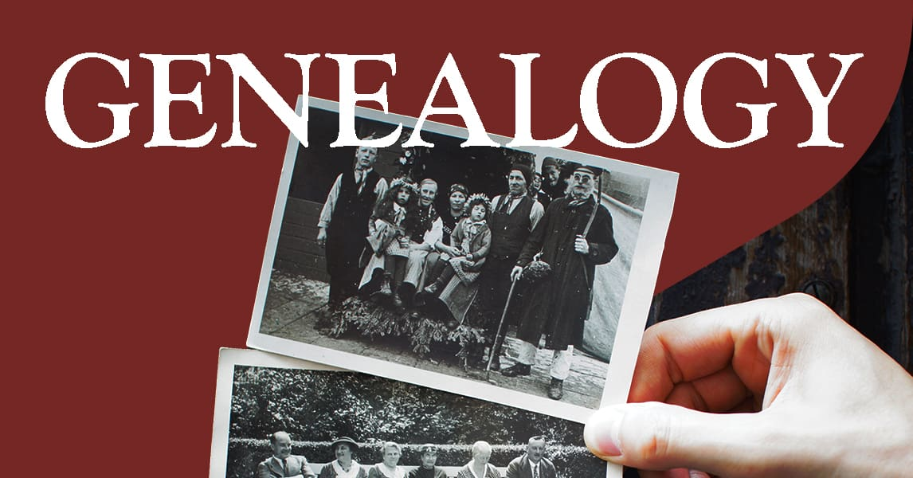
GENEALOGY DROP-IN CLASS
Remember too, that our meeting summaries and newsletters will be posted to the website rather than sent in a separate email to each member.

You can access the website at:

www.weseniors.ca/whats_new/genealogy-drop-in-class?

Trip to the Alberta Provincial Archives

Our April 1, 2026 meeting will be offsite at the Alberta Provincial Archives located at 8555 Roper Rd NW, Edmonton, AB, T6E 5W1.

Although a few months away, I am trying to gather an idea of numbers and ask that if you haven’t already done so, please send me an email (Yes or No) if you would like to attend this outing.
The Archives offers a wide array of research options – vital statistics, divorce records, probate records, homestead records, township maps, teachers Pension Ledger, Criminal Prosecution Files, Proof of Age Documents and a number of local histories, town directories, church records and indigenous resources.
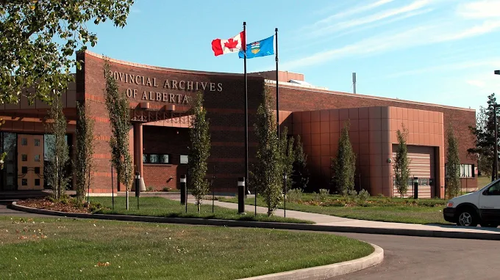

Prior registration is requested by the Archives. I will provide all those wishing to attend the necessary form(s) to complete prior to our visit.

Will AI one day build your Family Tree faster than you could brew a cup of coffee?
By Don Bowling

What does that mean for genealogists? Let’s explore that question by starting where AI began.
My first exposure to AI was watching tissue-box-sized robots learn to play soccer on a ping pong table. These soccer-playing robots used reinforced learning, AI that learns from its own experience.
A quick side note: Rich Sutton, a Professor of Computer Science at the University of Alberta, developed the concept of reinforcement learning in the 1980s. He is the recipient of the 2024 Turing Award. The Turing Award is presented annually to one or two individuals worldwide and is considered the highest honor in computer science—often referred to as the “Nobel Prize of Computing.” It recognizes major technical contributions of lasting
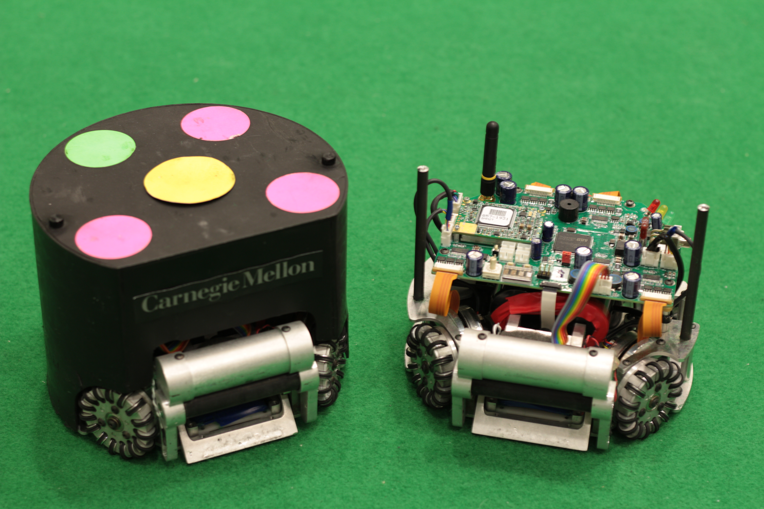
significance to the field.
My next exposure to AI here in Edmonton was watching machines using reinforcement learning and neural networks learn to play poker better than the best human players—making moves that baffled experts and earned international recognition. Neural networks are a form of machine learning inspired by the interconnectivity of the brain to recognize patterns in data.
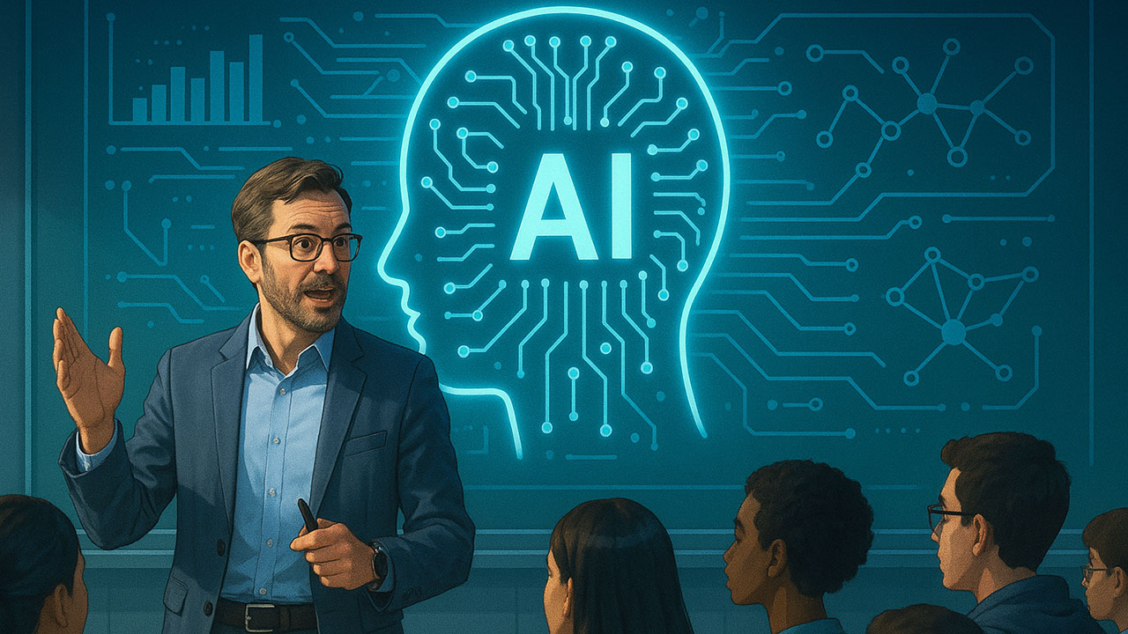
Today, neural networks and reinforcement learning form the basis of generative artificial intelligence. These models learn by processing (or “reading”) vast amounts of written text. Neural networks find patterns in this text, allowing it to generate new text. Reinforcement learning is used to train the models to make their output more likely to lead to correct answers and align with human preferences. Companies like Google and Microsoft have released versions of these models for public use. ChatGPT by OpenAI was the first to gain widespread attention,
opening the floodgates to both innovation and controversy.
Interestingly, neural networks were already at work in genealogy well before generative AI models appeared. Companies like FamilyTreeDNA (founded in 2000) and AncestryDNA (launched in 2012) likely use AI to analyze DNA and trace ancestral origins.
Today, generative AI models such as ChatGPT, Gemini, and Copilot are being used by both amateurs and professionals to research their family trees. We’ll explore how AI is transforming genealogical research in the next newsletter.
P.S. AI assisted in writing this piece

We are the Chosen in Each Family.
There is One who seems called to Find the Ancestors,
To put flesh on their bones and make them seem alive again,
To tell the Family Story and to feel that some how they know
That they approve that doing genealogy is not a cold gathering of facts,
But instead breathing life into all who have gone before.
We are the Storytellers of the Tribe.
Courtesy of Irene Powell

UPCOMING MEETINGS AND TOPICS – December 2025 to March 2026
Wednesday December 3. 2025 1:00 PM – 3:00 PM  Topic: Harnessing Artificial Intelligence for more Effective Genealogical Research & Storytelling  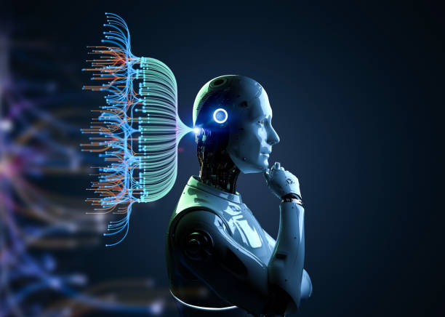  Jean-Yves Vanier-Verbeek’s presentation will highlight techniques for Harnessing Artificial Intelligence to improve genealogical research and storytelling. It begins by explaining the basic principles of AI, presents examples of its use in genealogy over the years, and discusses the arrival of ChatGPT in 2022 and its impact across various fields. He will then illustrate recent applications of AI in genealogy that support more effective research and storytelling, before concluding with a discussion of the limitations and challenges of AI as well as its future prospects.  As time permits, Don Bowling will demonstrate the use of some of the AI tools (ChatGPT, etc.). Don’s demonstration may be carried over to another future meeting as this is a valuable tool for us to understand as part of our genealogical research efforts. | Wednesday January 14. 2026 1:00 PM to 3:00 PM  Topics: 1. Naturalization Records – What are They and How can they help with Genealogical Research?  2. Googling for Grandma.  Thea Hawryluk will be presenting on the topic of Canadian Naturalization records – what are they, what value do they play in genealogical research, and where can we find them. Canadian Records go back as far as the 1820s through to the 1950s and can provide additional insight into our ancestors’ origins, residence, occupation, age and other valuable information.    Ashley Rother will present on the topic of “Googling for Grandma’ as developed by Cyndi Ingle, the creator and innovator behind the award-winning and globally recognized CyndisList.com. In a webinar presented by Cyndi she provides the following insight “Chances are that you are using Google on a daily basis. Chances are even better that you aren't using it to its full potential. Learn about Google's advance search options, and several more tools offered by Google that will enhance your research.”  
Wednesday February 4. 2026 1:00 PM – 3:00 PM  Topic: British Home Children  Dale Rutherford is arranging for a guest speaker to present on the heart-rending story of “The Little Immigrants” to Canada – The British Home Children. Over 100,000 impoverished children from the United Kingdom were sent to British dominions such as Canada, Australia, and New Zealand between the 1860s and 1940s. Facilitated by charitable organizations, they were sent with the belief that they would have a better life although many were sent to work as cheap labour on farms and in households. While some had positive experiences, many faced abuse, neglect, and hardship.  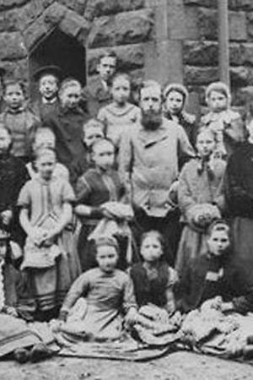  The presentation may be in person or via Zoom. | Wednesday March 4. 2026 1:00 PM – 3:00 PM  Topics:  1. Cemeteries and Family Research  2. Homestead Records  1. The value of information found in cemeteries and cemetery records goes unsaid. Thea Hawryluk will be presenting on the sources available using cemetery records to research your ancestors. These records provide a fascinating insight into the story of our family above and beyond just names and dates.    2. Hazel Elborne will be presenting on the use and role of Homestead Records as part of genealogical research. Homestead records are useful in genealogical research because they contain both land and biographical information about the applicant such as age, place of birth, former place of residence, date of entry on the land, marital status and naturalization record if available.  